4. Write an assembly language program for subtracting two 16-bit data using 8086 processor.

Program:

LDA 8500

MOV B, A

LDA 8501

MOV C, A

LDA 8509

MOV D, A

LDA 8510

SUB C

STA 8504

MOV A,

Output:

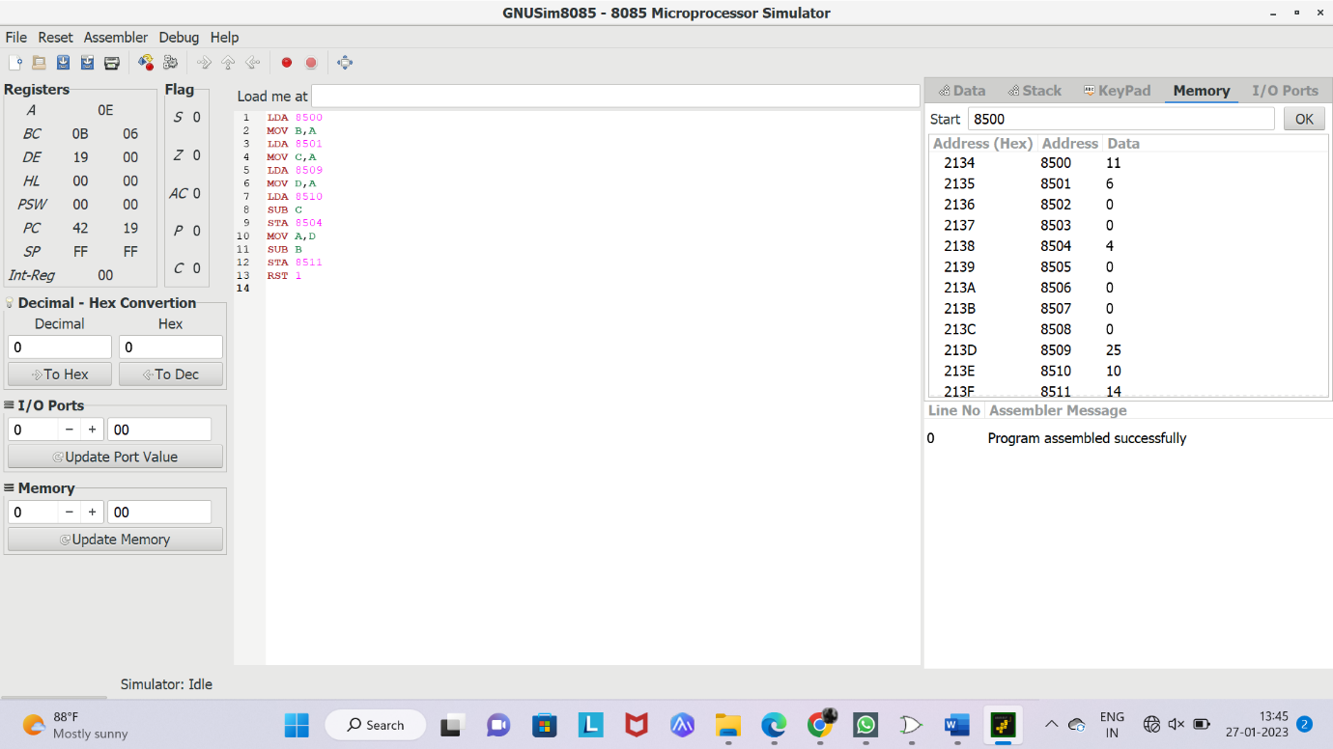

D

SUB B

STA 8511

RST 1